Creating Accessible Documents

Microsoft Word, Microsoft Excel, Microsoft PowerPoint, and PDFs

Table of Contents

1. Introduction 5

1.1. Document Purpose 5

2. Built-In Automated Checks 5

2.1. Built-In Accessibility Checkers in Office Apps 5

2.2. Accessibility Checker in Adobe Acrobat 6

3. Accessibility Standards and Practices 8

3.1. Web Content Accessibility Guidelines (WCAG) 8

3.1.1. The POUR Principles 8

3.1.2. Levels of Conformance 9

3.2. Section 508 9

3.3. Accessible Electronic Document Community of Practice (AED CoP) 9

4. Accessibility Concerns Shared by All Doc Types 10

4.1. File Formatting 10

4.1.1. Proper File Type 10

4.1.2. Descriptive File Name 10

4.1.3. Editing Restrictions in Documents 11

4.1.4. Macros 11

4.2. Content Formatting 11

4.2.1. Color Contrast Ratio 11

4.2.2. Color Formatting 12

4.2.3. Avoid Flashing Objects 12

4.2.4. Avoid Using Forms 13

4.2.1. Link Formatting 13

4.2.2. Ensuring Vital Background Information is Accessible 14

4.2.3. Embedded Media Descriptions in Documents 15

4.2.4. Alternative Text (Alt Text) 15

5. Microsoft Word Documents 17

5.1. Disable Restricted Editing in Word 17

5.2. Reveal Formatting Pane 17

5.3. Headings 17

5.3.1. Testing Headings 18

5.3.2. Custom Headings 18

5.4. List Formatting 19

5.4.1. Testing Lists 19

5.4.2. Ordered versus Unordered 19

5.5. Column Formatting 19

5.5.1. Testing Column Formatting 20

5.6. Table Formatting 20

5.6.1. Inserting a Table in Word 21

5.6.2. Text Wrapping and Tables 21

5.6.3. Testing Table Formatting 22

5.6.4. Data Table Formatting 22

5.7. Language Formatting 23

5.7.1. Setting a different language 24

5.7.2. Testing Language Formatting 24

5.8. Image/Object Formatting 25

5.8.1. Inline with Text 25

6. Microsoft Excel Documents 27

6.1. Remove Restricted Editing in Excel 27

6.2. Organize Content and Ensure Logical Reading Order 27

6.3. Data Tables 28

6.3.1. Adding an Accessible Table in Excel 28

6.3.2. Is it a Table or a Picture? 28

6.3.3. Is the Header Row properly recognized? 29

6.3.4. Does the table have a name? 30

6.4. Adding Alt Text to Images and other Objects in Excel 31

7. Microsoft PowerPoint Documents 31

7.1. Remove Restricted Editing in PowerPoint 31

7.2. Clean Presentation Layout and Logical Reading Order 31

7.2.1. Slide Layout 33

7.3. Reading Order 33

7.3.1. Hiding Objects in Selection Pane 33

7.4. Formatting Columns 33

7.5. Formatting Lists 34

7.6. Auto-Creating Data Tables 35

7.6.1. Identify a Header Row 35

7.6.2. Table Color Contrast and Borders 36

7.6.3. No Pictures of Tables 36

7.7. Headers and Footers in PowerPoint 36

7.8. Language Formatting 37

8. PDF Documents 37

9. Resources 37

9.1. Government Sites and Documents 38

9.2. Microsoft Sites and Documents 38

9.3. W3C Sites and Documents 38

9.4. AED CoP Links 38

9.5. Additional Resources 38

10. Glossary 38

11. References 39

12. Change Log 39

1. Introduction

Creating Accessible documents is incredibly important for the progression of society. An inaccessible document locks people out of information through no fault of their own. This can result in poor communication of information, lack of educational/employment opportunities, alienating individuals, and more. By creating accessible documents, you help avoid these issues and make the world a more inclusive place for all.

* 1. Document Purpose

This document will help guide you through some of the best practices regarding creating Accessible documents and some of the factors that influence what is considered accessible. Additional resources that can help you better understand the content presented here can be found in the **Resources** section later in this document.

This document is not an exhaustive list of methods, regulations, and features that relate to Accessibility by any means. New features are being added and we are finding different methods that work based on Accessibility need every day. Accessibility is ever evolving just like technology and society. This guide is meant to give you a place to start your journey towards helping make the world a bit more Accessible for all.

1. Built-In Automated Checks

Office applications, and many Adobe applications, feature built-in Accessibility Checkers. These will run automated checks on documents to find many common issues that may be present.

However, it is also important to ensure you perform manual checks as well. Some things could be marked as issues when they aren’t, or not marked as issues when they are. Automated checks cannot always account for what kind of data is present in the document, which may impact how it needs to be formatted to be considered accessible.

For instance, a data table is different from a decorative or formatting table. They have different formatting requirements, but an automated check is not going to be able to accurately make the distinction.

* 1. Built-In Accessibility Checkers in Office Apps

Office apps, both desktop and web based, have an Accessibility Checker built in since the 2016/2019 based versions. These are commonly accessed using the **Review** ribbon in the menu bar, or by going to “**File** ribbon > **Info** > **Check for Issues** > **Check Accessibility**.”

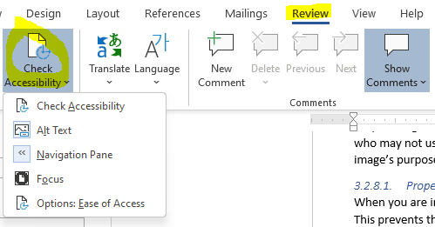

Figure 1: Check Accessibility under the Review ribbon in Word

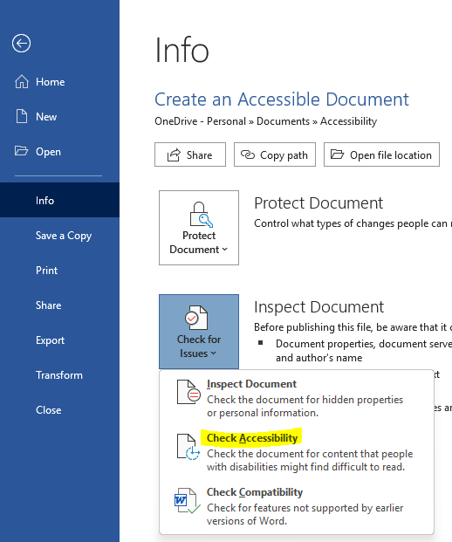

Figure 2: Info pane under the File ribbon with the Check Accessibility option highlighted

* 1. Accessibility Checker in Adobe Acrobat

Adobe Acrobat contains a built in Accessibility Checker tool that is accessed using the **Accessibility Tools** button.



Figure 3: Accessibility Tools

Once in the Accessibility Tools options you will be given the option to set “Reading Options” for when you have Adobe Acrobat run its built-in document reader, run a “Full Check”, or render an “Accessibility Report” for the file.

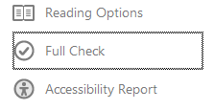

Figure 4: Accessibility Full Check Command

If you select to do a “Full Check”, you will be presented with a variety of customization options for your scan and then you can click “Start Checking” to begin the scan, or “Cancel” to exit without running a scan of the file.

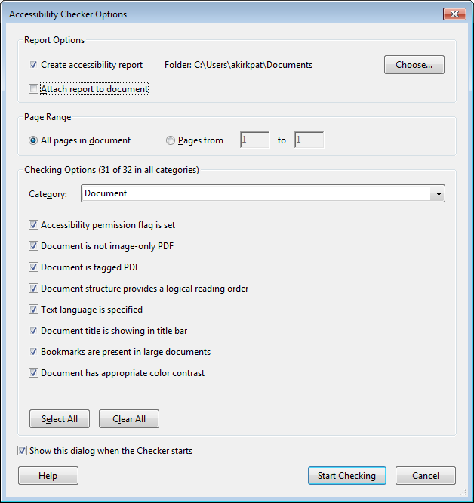

Figure 5: Accessibility Checker Option Dialogue

If you run a check, you will be presented with a report at the end that describes the results of the check so you can resolve any issues found if needed.

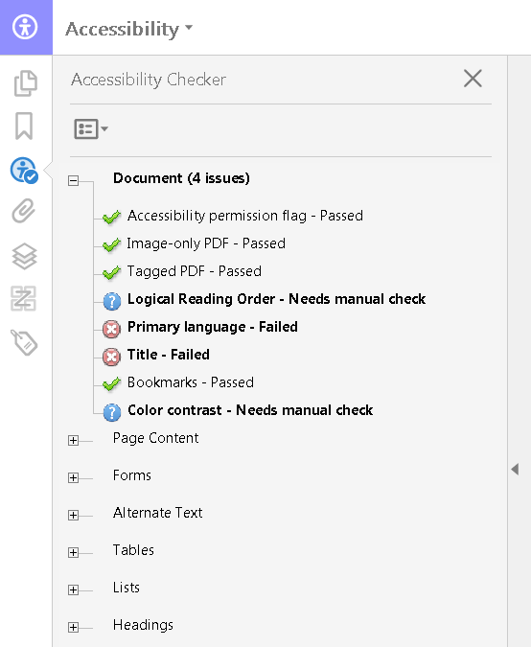

Figure 6: Accessibility Checker Results Panel

After a check has been run, it can be formatted into a report.

Learn more about the Adobe Acrobat built-in Accessibility checker at the following Adobe article: [Using the Acrobat Pro DC Accessibility Checker](https://www.adobe.com/accessibility/products/acrobat/using-acrobat-pro-accessibility-checker.html)

1. Accessibility Standards and Practices

There are a variety of regulations, standards, and practices revolving around Accessibility. This section will cover some of the most commonly recognized ones relevant to individuals within the United States (US), or working with US companies and/or organizations.

* 1. Web Content Accessibility Guidelines (WCAG)

The **Web Content Accessibility Guidelines** (**WCAG**), were developed by the **Web Accessibility Initiative** (**WAI**) of the **World Wide Web Consortium** (**W3C**) in cooperation with various individuals and organizations worldwide. They were initially published in 1999 and have since undergone multiple revisions. As of July 2021, the current version is 2.1, which was first approved in June 2018. Version 2.2 is scheduled to be finalized by the end of 2021.

The WCAG have become the foundation for most Accessibility regulations, standards, and practices. Section 508, ADA, and more are heavily influenced by the evolution of WCAG. In many cases, meeting the recommended level of conformance with WCAG standards will get you incredibly close to meeting any accessibility regulations you are required to meet for documents, web applications, and software applications.

* + 1. The POUR Principles

As of version 2.1, WCAG focuses on 13 Guidelines divided into 4 primary principles known as the POUR principles, which are **Perceivable**, **Operable**, **Understandable**, and **Robust**. Each of these 4 principles is laid out in the following sub-sections with their applicable guidelines listed. View the [WCAG 2.1 site](https://www.w3.org/TR/WCAG21/) for more information on each principle along with its relevant guidelines and success criterion.

* + - 1. Perceivable

The **Perceivable** principle states that Information and user interface components must be presentable to users in ways they can perceive.

* + - * 1. Relevant Perceivable Guidelines

The main guidelines that apply to the Perceivable principle include:

* **Guideline 1.1:** Text Alternatives: Provide text alternatives for any non-text content so that it can be changed into other forms people need, such as large print, braille, speech, symbols, or simpler language.
* **Guideline 1.2:** Time-based media: Provide alternatives for time-based media.
* **Guideline 1.3:** Adaptable: Create content that can be presented in different ways (for example simpler layout) without losing information or structure.
* **Guideline 1.4:** Distinguishable: Make it easier for users to see and hear content including separating foreground from background.
  + - 1. Operable

The **Operable** principle states that user interface components and navigation must be operable.

* + - * 1. Relevant Operable Guidelines

The main guidelines that apply to the Operable principle include:

* **Guideline 2.1:** Keyboard Accessible: Make all functionality available from a keyboard.
* **Guideline 2.2:** Enough Time: Provide users enough time to read and use content.
* **Guideline 2.3:** Seizure and Physical Reactions: Do not design content in a way that is known to cause seizures.
* **Guideline 2.4:** Navigable: Provide ways to help users navigate, find content, and determine where they are.
* **Guideline 2.5:** Input Modalities: Make it easier for users to operate functionality through various inputs beyond keyboard.
  + - 1. Understandable

The **Understandable** principle states that information and the operation of user interface must be understandable.

* + - * 1. Relevant Understandable Guidelines

The main guidelines that apply to the Understandable principle include:

* **Guideline 3.1:** Readable: Make text content readable and understandable.
* **Guideline 3.2:** Predictable: Make web pages appear and operate in predictable ways.
* **Guideline 3.3:** Input Assistance:Help users avoid and correct mistakes.
  + - 1. Robust

The **Robust** principle states that content must be robust enough that it can be interpreted reliably by a wide variety of user agents, including assistive technologies.

* + - * 1. Relevant Robust Guidelines

The main guidelines that apply to the Robust principle include:

* **Guideline 4.1:** Maximize compatibility with current and future user agents, including assistive technologies.
  + 1. Levels of Conformance

Each guideline is divided up into Success Criteria that better define how to reach one of the 3 levels of conformance to WCAG standards for a particular guideline. These levels are **A**, **AA**, and **AAA**.

Conformance level **A** is considered the lowest level of conformance and level **AAA** is the highest. In general, it is recommended that you aim for at least AA level conformance overall, and AAA where applicable and/or possible.

AAA tends to be more specialized in terms of audience and material presented. It is not possible to meet all success criteria for AAA conformance. You can learn more about WCAG conformance levels by reading the [Conformance](https://www.w3.org/TR/WCAG21/#conformance) section of WCAG 2.1.

* 1. Section 508

In 1986, Section 508 (29 U.S.C. § 794d) was added as an amendment to the Rehabilitation Act of 1973. The amendment was added to help remove barriers to information that can prevent access by individuals with disabilities. It applies to the way in which Federal agencies develop, procure, maintain, and use **Information and Communication technologies** (**ICT**).

Section 508 requires US Federal agencies and federal contractors receiving funds from the US government to make their electronic and information technology accessible to their employees and members of the public with disabilities that is comparable to the access granted to others.

* 1. Accessible Electronic Document Community of Practice (AED CoP)

The **Accessible Electronic Document Community of Practice** (**AED CoP**), which is a part of the Federal CIO Council, was created by a group of Federal Subject Matter Experts (SMEs) with the goals of:

* Improving accessible content posted on Federal agency websites
* Advancing the field of accessibility
* Creating reusable accessibility information and artifacts

They created various guides containing steps that can be used to make an electronic document Section 508 compliant.

1. Accessibility Concerns Shared by All Doc Types

The items in this section are Accessibility concerns regardless of doc type. So they are listed here rather than repeating them in each doc type section.

* 1. File Formatting

Items in this section deal with how you set up the file itself before adding in content.

* + 1. Proper File Type

Make sure to save documents with the newest file extension for the respective app. This helps to ensure better compatibility with newer **Assistive Technology** (**AT**).

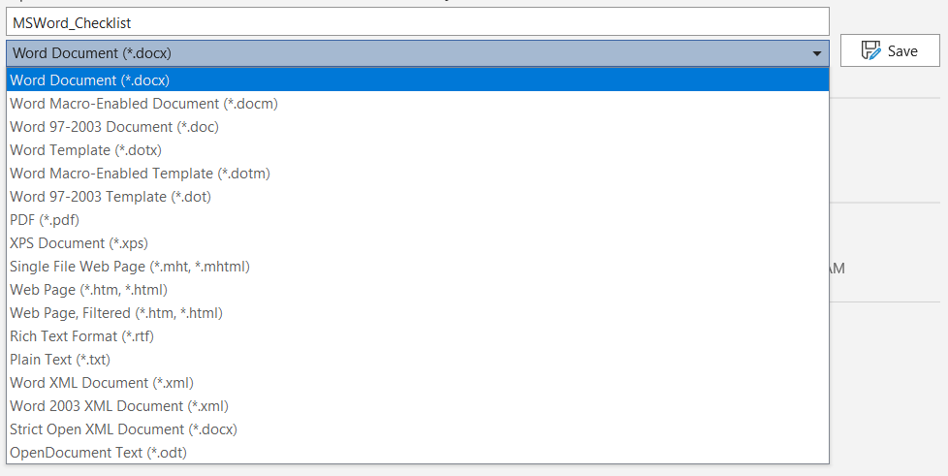

Figure 7: Microsoft Word file save dialogue.

A list of some of the relevant file extensions can be found below:

* **Microsoft Word:** .docx instead of .doc
* **Microsoft Excel:** .xlsx instead of .xls, .csv, or .xml
* **Microsoft PowerPoint:** .pptx instead of .ppt
  + 1. Descriptive File Name

Ensure the file name helps to differentiate the file from other files and gives the user an idea of what the document contains. Doing so also helps all users more readily identify an individual document amongst a group of documents. When the file names are descriptive, finding a specific file is far quicker even under stressful circumstances.

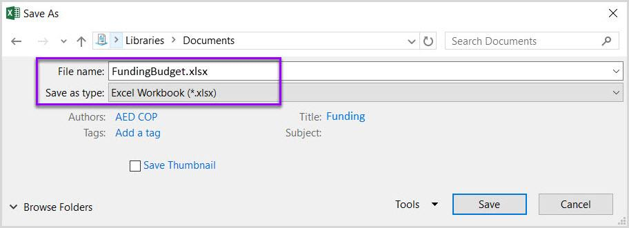

Figure 8: Excel file with .xlsx file extension and descriptive name

The table below gives examples of file names that are not descriptive, versus ones that are. This also helps to visualize how these documents would look like if they were all grouped together in the same location.

|  |  |
| --- | --- |
| Non-descript Filename Example | Descriptive Filename Example |
| Untitled.docx | MSWord_Checklist.docx |
| Untitled.xlsx | Budget2021.xlsx |

Table 1: Filename examples

* + 1. Editing Restrictions in Documents

Document restrictions limit or prevent users of AT from reading or editing the document in part because they interfere with how AT interact with the file content. If you must use document restrictions, ensure assistive technology users have access to the password necessary to turn them off. In some cases, AT may make minor alterations to a document to make it accessible to the user, or may need to interact with elements beneath the content to properly hook in and interpret it for the user.

To help you visualize it, think of when you open a Microsoft Office document from online and the Office application won’t let you print it or edit the file until you manually save it to your computer. This is a form of document editing restriction, often caused by the document initially being in a temporary file location or a form of protection that may be turned on to prevent documents from potentially unsafe locations from causing trouble.

**NOTE:** Ways to disable restricted editing in particular documents are listed under their respective sections of this document.

* + 1. Macros

When testing a document containing macros for accessibility, it is important to use a more software baseline method of Accessibility testing. Documents containing macros tend to have a different file extension from those that do not. Some example file extensions are listed below:

* **Microsoft Word: docm** or **dotm**
* **Microsoft Excel: .xltm** or **.xlsm**
* **Microsoft PowerPoint: .pptm** or **.potm**
  1. Content Formatting

The following items are content formatting elements that are shared across doc types, and the methods by which they are applied are fairly similar or intuitive enough to generally not require explanation.

* + 1. Color Contrast Ratio

**Contrast ratio** is the ratio between maximum and minimum brightness. A proper contrast ratio ensures that there is enough difference between 2 colors that they are less likely to blur together as the brightness of a screen is changed, and helps make content more distinguishable as the surrounding light increases and decreases. Contrast ratio is impacted by the colors, font size, and font weight.

Improper contrast can make reading content difficult for everyone, particularly those who are colorblind or have low vision. If your content is effectively black on a white background, or close to it, you probably have nothing to worry about. However, it is a good idea to test to be sure. The [Color Contrast Analyzer tool](https://www.tpgi.com/color-contrast-checker/) is great for this, and is the tool recommended by the DHS OAST for their Trusted Testers. It is available for Windows and Mac.

Once you have the tool downloaded and installed, you can launch it. From there you can manually enter color Hexes, select them from a menu, or use the dropper tool to select the section whose color you wish to use in your comparison. From there the tool will tell you if the colors contrast enough to pass AA and/or AAA WCAG compliance.

AA is typically considered the minimum goal to achieve, with AAA being great if you can without impacting your ability to at least meet AA in other areas, or impacting the function of your file, document, and/or application.

Please note that some color combinations may only pass if they are large text, and not if they are standard size text. You can see more details in the table below:

|  |  |
| --- | --- |
| Type or Size of Text | Contrast Ratio |
| Standard Text (12 pt regular) | 4.5:1 |
| Large Test (14 pt bold or 18 pt regular) | 3:1 |

Table 2: Table detailing font sizes and expected contrast ratios

It is important to note that incidental text, text overlaid on images, and logotypes are excluded from this requirement.

|  |  |
| --- | --- |
| Good Color Contrast | Insufficient Color Contrast |
| White text on black background  Approximate ratio 21:0:1 | Dark gray text on a black background  Approximate ratio 3:1 |
| Dark green text on yellow background  Approximate ratio 7.6:1 | Orange text on a yellow background  Approximate ratio 2.1:1 |
| Light blue text on dark blue background  Approximate ratio 10.5:1 | Red text on a dark blue background  Approximate ratio 1.1:1 |
| White text on a red background  Approximate ratio 6.5:1 | Dark green text on a red background  Approximate ratio 1.3:1 |

Table 3: Examples of good and insufficient contrast for comparison

* + 1. Color Formatting

Color formatting is important to ensure visual elements are clearly visible and their information is more clearly conveyed. This means making sure that information is not purely conveyed using color or shapes.

If information is only conveyed through shapes or colors, you will not give comparable access to individuals who are blind, colorblind, or have low vision. You risk an inconsistent conveying of information because the colors or shapes could be interpreted differently by different people based on how they are able to view it. As a result, it is important to use additional methods to convey meaning if color or shape would be the sole method otherwise.

Please note that the table below lists the color names under the example labeled “List using only colors” to ensure someone using AT knows what is being shown while still being able to have the effect of no relevant information about the list being conveyed. If you included text describing the color in the field, it could technically count as conveying the needed information, if you described elsewhere what the colors represent in the context.

|  |  |
| --- | --- |
| Project | Status |
| Project A | [Color Green] |
| Project B | [Color Yellow] |
| Project C | [Color Red] |

Table : Project Status table with statuses only conveyed using colors:

|  |  |
| --- | --- |
| Project | Status |
| Project A | On Time |
| Project B | At Risk |
| Project C | Late |

Table : Project Status table with statuses conveyed using text and color.

* + 1. Avoid Flashing Objects

Except for PowerPoint documents, flashing objects are not considered accessible in most doc types since you often cannot properly control how frequently they flash or have controls to stop them from playing located in a quickly accessible location for the user. As a result, they can pose a lot of dangers for individuals with certain seizure conditions.

It is highly recommended to avoid using flashing elements in all documents altogether. If you feel you must include a flashing object, limit the flashes to 3 or less per second, and give the user a way to disable it if at all possible.

* + 1. Avoid Using Forms

You cannot create a Word, Excel, or PowerPoint document with form fields that is considered Section 508 compliant. It is better to create forms in a web/software application or PDF where additional tools are available to properly associate fields and labels, and ensure proper navigation.

* + 1. Link Formatting

Most AT will recognize links as being links if they are interactive links. If they are simply text, then it will read them off as text. However, there are other things you need to be aware of when creating links; if your intent is to make them the best they can be.

* + - 1. Descriptive Link Text

The link text needs to be descriptive of what the link navigates too. Do not simply label them as “Click Here” and often it is good to avoid spelling out the full URL unless the document is to be printed, or the link is relatively short and clear in meaning. The table below shows 3 examples:

|  |  |  |
| --- | --- | --- |
| Uniquely Named Link | Link Determinable within context | An unclear link name with no context |
| [www.section508.gov](http://www.section508.gov) | [Get My Section 508 Questions Answered](https://section508.gov/content/help-and-faq) | [click here](https://www.opm.gov/) |

Table 6: Link formatting examples

A lengthy URL may seem to not be problematic, but they can be cumbersome to users regardless of whether they are using AT. This is particularly the case when the links are included in with other text. Below is an example using the URL for a job posting as an example:

|  |  |
| --- | --- |
| Full URL | Link Formatted with Descriptive Text |
| <https://recruiting2.ultipro.com/SOR1001SORE/JobBoard/1fe5e40e-4e0c-4b11-86e3-9a8e1f396263//OpportunityDetail?opportunityId=0102542c-4a92-46ca-b366-cbf35fced749&utm_source=LINKEDIN&utm_medium=referrer> | [Software Test Engineer | Sorenson Communications, LLC Opportunities (ultipro.com)](https://recruiting2.ultipro.com/SOR1001SORE/JobBoard/1fe5e40e-4e0c-4b11-86e3-9a8e1f396263/OpportunityDetail?opportunityId=0102542c-4a92-46ca-b366-cbf35fced749&utm_source=LINKEDIN&utm_medium=referrer) |

Table 7: Full URL versus Descriptive Link Text

Which of the above examples would be more pleasing to see in a paragraph?

Which link has a meaning that is easier to identify?

Which would you prefer having read off to you? This is particularly important since most AT will state that a link is a link if it is an interactive link. AT will then proceed to read the displayed text for the link. As a result, if you just have the URL written out, the AT user will have to listen to a lengthy URL rambled off to them that may not give them any additional useful information about the link’s purpose.

* + - 1. Microsoft Edge and Links

If you copy a link from Microsoft’s Chromium-based Edge browser into Microsoft Word, you may notice that it will automatically format the link text with the page’s title. This can be helpful for pasting a link into a document with already accessible, descriptive link text. However, you may want to edit it down some depending on how the web page designer formatted their page titles. For example, in the previous job posting example, you may want to edit it down so it reads better in the context of other text as shown below:

|  |  |
| --- | --- |
| Original Pasted Link Text | Edited Link Text |
| [Software Test Engineer | Sorenson Communications, LLC Opportunities (ultipro.com)](https://recruiting2.ultipro.com/SOR1001SORE/JobBoard/1fe5e40e-4e0c-4b11-86e3-9a8e1f396263/OpportunityDetail?opportunityId=0102542c-4a92-46ca-b366-cbf35fced749&utm_source=LINKEDIN&utm_medium=referrer) | [Software Test Engineer job posting with Sorenson Communications](https://recruiting2.ultipro.com/SOR1001SORE/JobBoard/1fe5e40e-4e0c-4b11-86e3-9a8e1f396263/OpportunityDetail?opportunityId=0102542c-4a92-46ca-b366-cbf35fced749&utm_source=LINKEDIN&utm_medium=referrer) |

Table 8: Descriptive Link Text Examples

* + 1. Ensuring Vital Background Information is Accessible

Information stored in the background, headers, footers, or in watermarks is not accessible to AT. Thus, this content should ideally be duplicated near the beginning of the document, cell A1 if in a spreadsheet, if it is vital to properly understanding and distributing the document’s content.

For example, if you have a watermark stating that the document is confidential or a draft. This is information that can impact the user’s understanding of the content, and how they share the content with others. Thus, it should be duplicated within the body of the document, preferably near the top of it. Some examples are shown below:

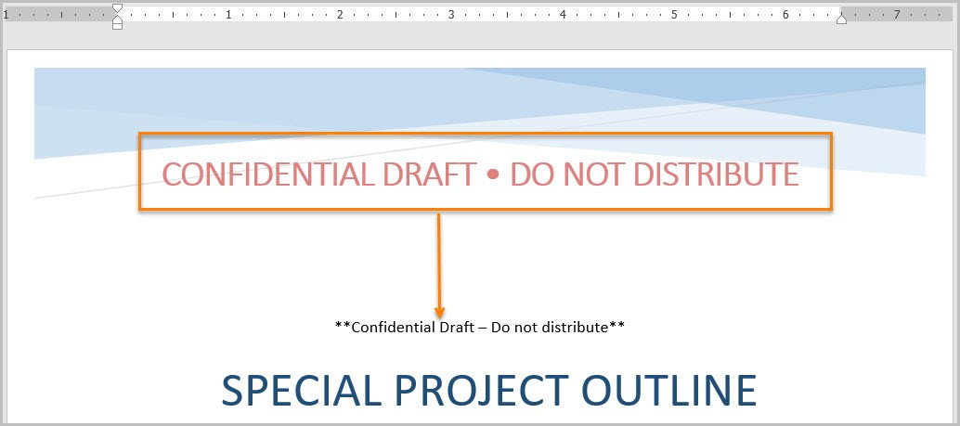

Figure 11: Example of a watermark displayed in the body of a Word document

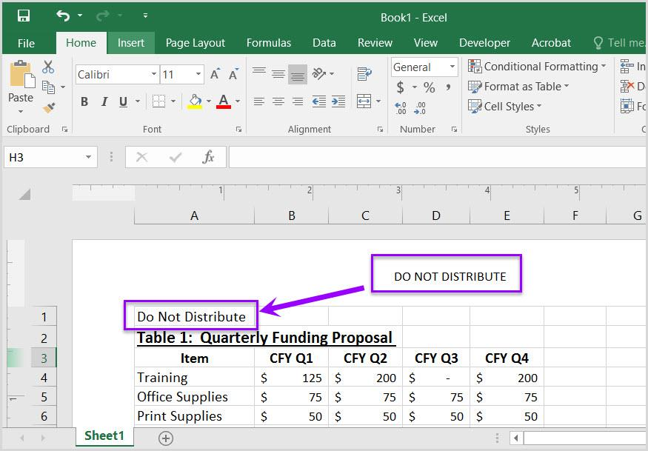

Figure 12: Example of vital information repeated in cell A1 of the worksheet

**NOTE:** PowerPoints are different in this regard. In PowerPoints it is possible to add the header and/or footer to the reading order. A section titled “Headers and Footers in PowerPoint” has been included under the PowerPoint portion of this document that explains how to do this.

* + 1. Embedded Media Descriptions in Documents

Information in this section applies if you have embedded audio, video, or multimedia files. Ensure there is the following for each of these media types:

* **Audio Only**
  + Accurate and complete transcript
* **Video Only**
  + Accurate and complete text description
* **Synchronized Media (Audio and Video)**
  + Accurate and complete synchronized captions and audio descriptions
    1. Alternative Text (Alt Text)

It is important that all images, and other objects like smart shapes, have clear descriptive text if they convey meaning in the document.

**NOTE:** Technically, you do not need alt text if there is text near the image describing it, though alt text can still help identify the image so the user can associate the image with the surrounding text rather than risk it being identified generically as an image when the user selects it. Alt Text can also help provide additional visual information that is needed and not included in the surrounding text, or caption, but helps the user better understand the context of the image.

In most cases, it is best to limit it to 1-2 sentences unless more detail is needed. The pane will give additional recommendations for things to consider when typing alt text.

When trying to figure out what to write for alternative text, think about the purpose of the image and not what the image looks like. The alternative text should fully convey the meaning of the image and not focus on what the image is. If you replaced the image with just the alternative text, would key information be lost? If the answer is no, you most likely provided properly descriptive Alt Text.

Make sure to include any text present in the object, and include alt text for logos since they are always considered informative. Make sure that the alt text is descriptive and accurately represents what is conveyed by the object.

* + - 1. Adding Alt Text in Office Applications

Adding Alt Text is super easy. Simply right-click an image, or other object, and select the “Edit Alt Text” option from the context menu that displays. An **Alt Text** pane will display where you can type in a brief description of the image.

Additional information on adding Alt Text in Office applications can be found in the following Microsoft Support video/article: [Improve accessibility with alt text](https://support.microsoft.com/en-us/office/video-improve-accessibility-with-alt-text-9c57ee44-bb48-40e3-aad4-7647fc1dba51).

**NOTE:** There are additional considerations that need to be made for alt text in Excel documents. Please view the alt text section of the Excel portion of this document for details.

* + - 1. Adding Alt Text in Adobe Acrobat

To add Alt Text to an image, or other object, in an Adobe Acrobat PDF, you can use the **Accessibility Tools** or the **Tags** panel. Additional information on adding Alt Text to PDFs can be found in the following Adobe article: [PDF Accessibility Repair: Examine the Document](https://www.adobe.com/accessibility/products/acrobat/pdf-repair-add-alternative-text.html).

* + - 1. Decorative Images/Objects

If an image is decorative, for example a background image, stylized borders, or one that just adds color to the document. These are things that do not convey any information to the reader. Open the **Alt Text** pane as described in the previous section, but make sure to check the box labeled “Mark as decorative.”

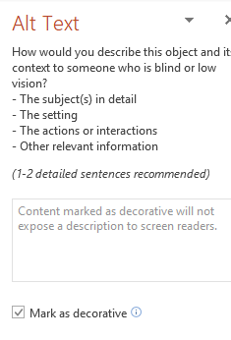

Figure : Alt Text options in PowerPoint

If the “Mark as Decorative” option is not available, you can indicate that an image is decorative by placing 2 quotes with a single space between them (“ ”) in the “Description” field provided under the Alt Text options.

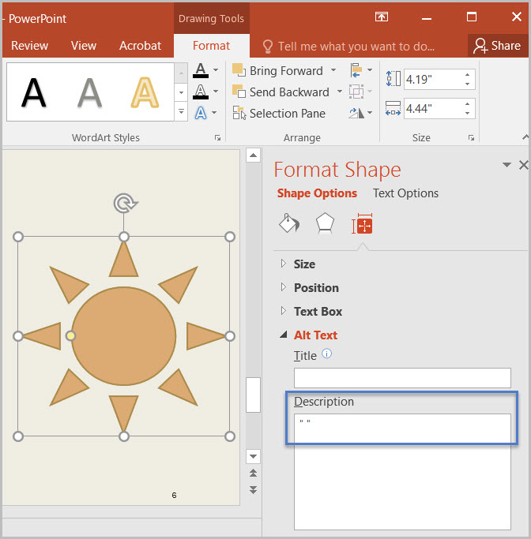

Figure : Alternative Alt Text options in PowerPoint with the quotes to indicate the image is decorative used.

1. Microsoft Word Documents

This section will detail ways to ensure your Microsoft Word documents are Accessible. Some of these are probably things you are doing already, but others may be things you never would have considered as needed to make the document accessible. Some things are required before you ever start adding content to the file.

* 1. Disable Restricted Editing in Word

As mentioned previously, editing restrictions in documents can make all, or part, of a document inaccessible. To turn off editing restrictions in Word documents:

1. Select the “Review tab>Restrict Editing”
2. Look to see if the “Stop Protection” button appears at the bottom of the “Restrict Editing” pane.
   1. If the “Restrict Editing” pane shows options 1, 2, and 3, then restricted editing is turned off.
3. Click “Stop Protection.”

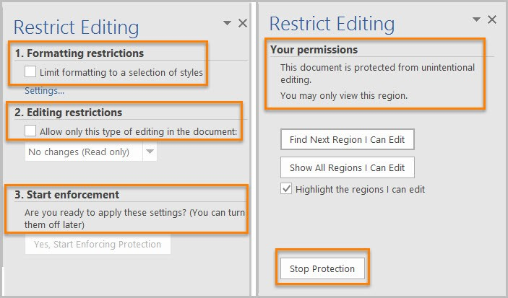

Figure 15: Restrict Editing pane options

* 1. Reveal Formatting Pane

Often you will see the **Reveal Formatting** pane listed as the method for testing whether something is formatted properly. Anytime you need to open this pane, simply:

1. Select the text you wish to inspect the formatting of or place your cursor within it.
2. Press the **Shift** key and the **F1** key together on your keyboard.

Doing so will open the **Reveal Formatting** pane.

* 1. Headings

If a text item is meant to be a heading, it is not enough for it to visually look like a heading. It needs to use a proper heading style in Word.

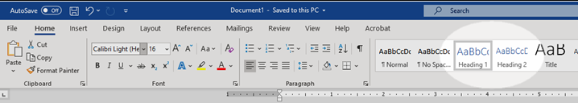

Figure 16: Heading Styles in Microsoft Word

* + 1. Testing Headings

To pass this, all headings must show up appropriately in the **Navigation pane** of Word. This is particularly important since Assistive technology can not infer meaning purely based on how you chose to manually format the text.

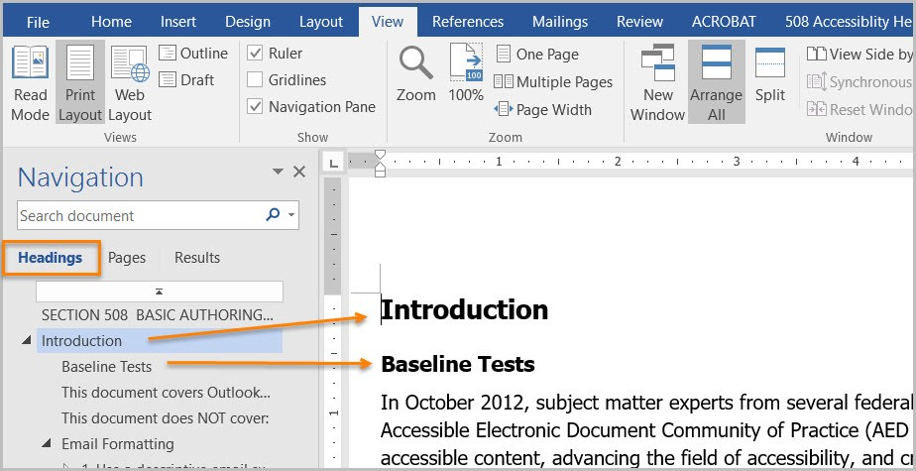

Figure 17: Microsoft Word Navigation Pane.

Properly formatted headings that show up properly in the Navigation pane also serve to make the content more easily navigated in general regardless of whether AT is being used.

* + 1. Custom Headings

If you need a custom heading look that is not offered by Microsoft Word, you can create a custom one. However, make sure to set the settings correctly so that the heading is recognized as the proper heading level by Word.

To do so, make sure to set the “**Style based on**” option to the appropriate heading level when you are modifying your new heading style. Also make sure to select “**Linked (paragraph and character)**” from the “**Style type**” drop-down if it is not already selected. Finally, set the “**Style for following paragraph**” to “**Normal**” to ensure that it automatically switches to the normal paragraph font when you go down the next line after a header.

It is also important that a custom heading have a descriptive name that helps identify what its purpose is. This will help anyone else using your custom heading later and will help you if you need to go back and use it in the future.

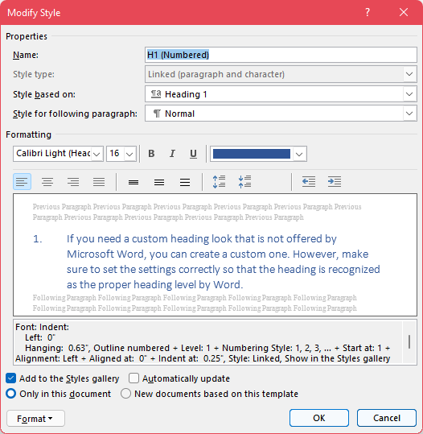

Figure 18: Modify style dialogue window

* 1. List Formatting

Lists being properly formatted in a document ensures that AT can properly infer order and meaning. This means making sure to use list styles built into Microsoft Word. Word does give you the option to make custom list styles, similar to how you can make custom heading styles.

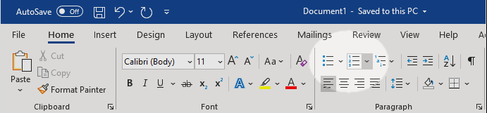

Figure 19: List style buttons in Microsoft Word

* + 1. Testing Lists

You can check if a list is properly counted as a list using the **Reveal Formatting pane**. If it is properly formatted, you will see the list information displayed in the pane.

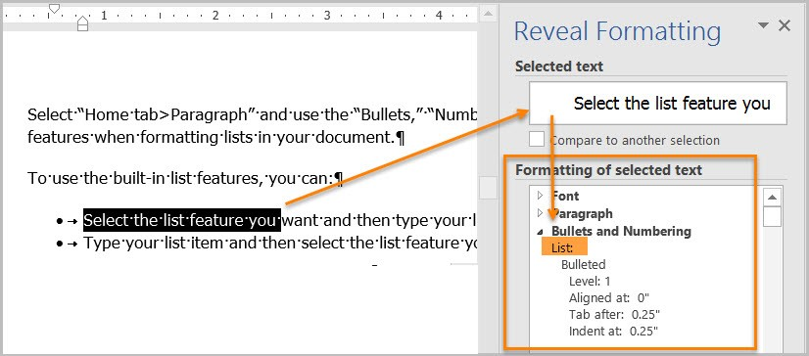

Figure 20: Microsoft Word Reveal Formatting pane

* + 1. Ordered versus Unordered

**Ordered lists** are used to indicate that the order of the items in the list is significant. They are typically used for lists of steps that need to be completed in a particular order. These lists are typically formatted with list markers like Roman numerals, Arabic numerals, or other alphanumeric characters where order has meaning.

Ordered list formatting should not be used for **Unordered lists**. Items in unordered lists don’t necessarily need to be listed in a particular order, though you may still choose to list them in some form of logical order (**e.g.** listing ingredients based on what part of the dish they are used in and the order in which those parts are made in the instructions). Unordered lists could include lists of ingredients in a recipe, hardware in a box, etc.

* 1. Column Formatting

When you wish to organize content in a Word document into columns, it is important to use the built in **Column** options to do so. Attempting to give content the look of being in columns using tables, tabbing, or spaces will cause AT to not read the content correctly.

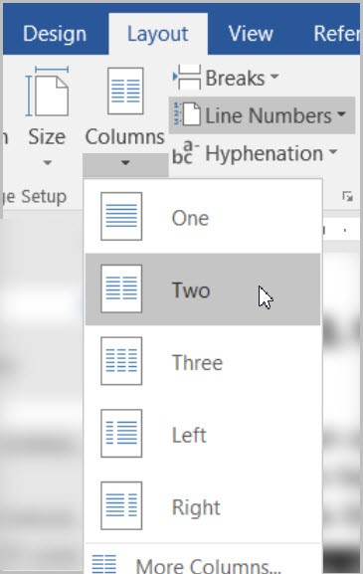

Figure 21: Column options in Word under Layout Tab

* + 1. Testing Column Formatting

You can use the **Reveal Formatting** pane to test whether columns are properly formatted and recognized by Word as columns. Your content fails if you place your cursor within content that visually appears to be in a column format, but the Reveal Formatting pane does not list them as being in columns.

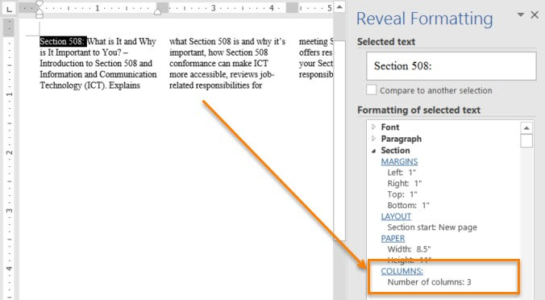

Figure 22: Reveal Formatting pane recognizing columns

* 1. Table Formatting

Properly formatting tables in Microsoft Word ensures that information will be properly recognized by AT. You should make sure to use the built-in table inserting option, and not just visually create a table using spacing, tabs, or indentions. If content is merely formatted to visually look like a table without being inside a table, AT will not be able to properly infer that it is a table.

Do not use pictures of tables or tables with merged or split cells. These are not accessible because the table information is often not able to be properly conveyed by AT, or AT is unable to read the information in a meaningful way. Also do not nest one data table inside of another table.

* + 1. Inserting a Table in Word

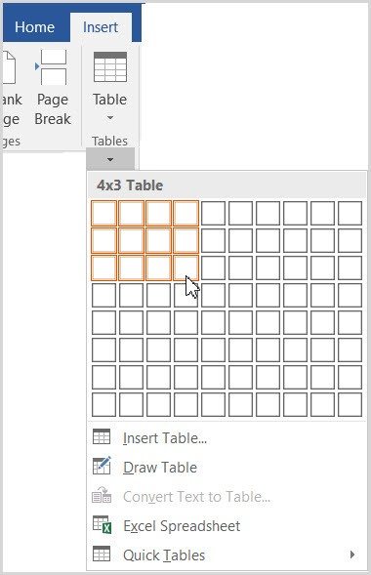

Figure 23: Table option found under the Insert ribbon in Word

After selecting the **Table** option under the **Insert** ribbon in Word, you can either manually select the number of columns and rows using the boxes displayed or select the **Insert Table** option to be taken to a dialogue box where you can type in the number of rows and columns you wish your table to have.

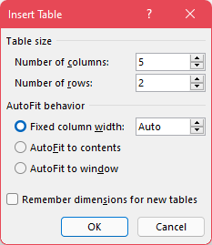

Figure 24: Insert Table window

* + 1. Text Wrapping and Tables

You should turn off Text Wrapping around tables in Microsoft Word. Allowing text to wrap around a table can cause AT to not properly read the table and the surrounding content.

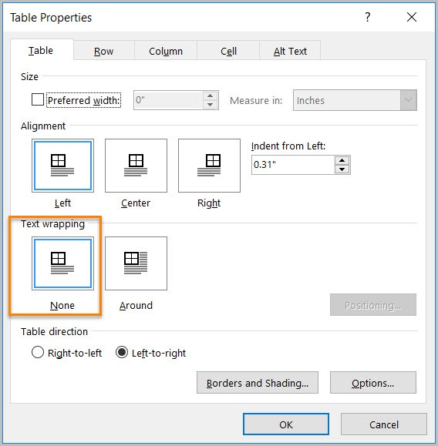

Figure 25: Table Properties window with text wrapping set to None

* + 1. Testing Table Formatting

The easiest way to test your table is whether you used the built-in table tool in Word to create it. If so, then you are okay. Your table fails if you instead used tabs, spacing, and indentions to create the visual look of a table.

Can you tab through your table? Does it tab through in a way that matches the visual layout of the content? Many AT users will use a keyboard to navigate content. Therefore, it is important to properly format a table in Word so that it can be properly tabbed through. If your table can be tabbed through, and the tab order matches the visual appearance of the table, your content passes.

* + 1. Data Table Formatting

**Data Tables** are tables where there is a specific relationship between cells. For instance, a header row that describes what information is stored in the cells below it.

Data tables can be problematic for AT if not properly formatting. The relationship between the individual data items can be lost. Generally, data tables are best saved for web applications where WAI-ARIA can be used to better define the relationship between different cells. They also work out better in Excel spreadsheets.

* + - 1. Avoid Split or Merged Cells

AT cannot properly identify the relationship between data in split and merged cells. As a result, it is best to avoid them at all costs in Word documents. This is a just because you can do it doesn’t mean you should circumstance.

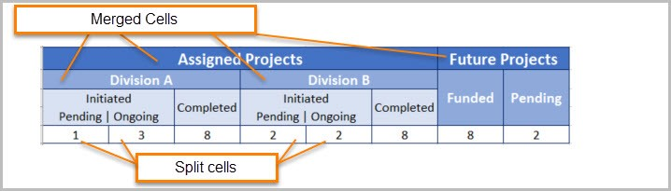

Figure 26: Complex table with merged and split cells

* + - 1. Don’t use pictures of tables

If you select a table and the “Picture Tools”, or “Picture Format”, ribbon shows up, your table fails because it is an image and not a table. AT will not be able to read the text in the picture, or at least will not be able to read it well enough to identify it as a table and convey the relationship between the various cells of the table.

* + - 1. Ensure the Header Row Repeats

Have you ever seen a table that went across multiple pages, but you had to keep scrolling up to the first page the table was on because the headers were only on that first page? Word has an option to repeat a header row across the top of each page the table is on so the user can easily see the column headers to remember what each is for.

**DO NOT** simply manually recreate the header row on each page. This can lead to confusion because the AT will not recognize the manually created header row as such unless the table on the next page is an entirely separate table from the portion of the table on the previous page.

You can check if a row is properly recognized as a header row and set to repeat by placing your cursor in a cell of the header row, opening the Reveal Formatting pane, and seeing it shows the row set to “Repeat as header row”.

To set this:

1. Place your cursor in one of the cells of the header row and right-click.
2. Select **Table Properties** from the context menu that displays.
3. Under the **Row** table in the **Table Properties**, you will see a check box labeled “Repeat as header row at the top of each page.”

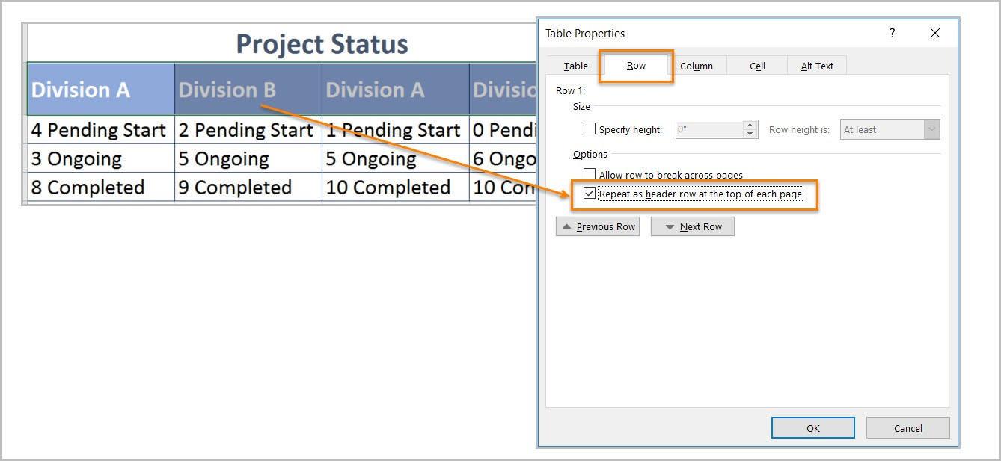

Figure 27: Table Properties with "Repeat as header row at the top of each page" checked.

It is advised to just turn this on for every table. That way you are covered if it does end up going across multiple pages.

* 1. Language Formatting

If your document is all in one language, then you don’t necessarily need worry about this. However, you can ensure Word recognizes the document as being in all one language by:

1. Highlighting all content in the document.
2. Navigate to the **Review** tab.
3. Click the **Language** button under the **Language** section.
4. Select the **Set proofing language** option.

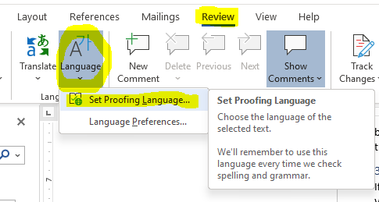

Figure 28: Language options in Word with Set Proofing Language selected.

1. Select the document’s primary language from the list, and click **OK**.

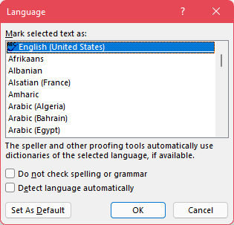

Figure 29: Proofing language selection menu.

This will ensure that Word recognizes the selected content as the correct language. This is important since it can impact how a screen reader, or other AT, pronounce a particular word when they read it off. Not properly setting the language for a section of text could cause it to be mispronounced, which can alter the meaning of some words.

* + 1. Setting a different language

If you have an individual word or block of text that is in a language other than the predominant one for the document, you can use the same methods shown about to set the language for just that section of text.

Simply highlight the section of text that is in a different language, and then navigate to the **Set Proofing Language** option, but select the language of that section instead of the predominant one for the document.

* + 1. Testing Language Formatting

To test language formatting, refer to the **Reveal Formatting pane** used in previous sections. This time, make sure to place your cursor within the section of text that you know if a language other than the predominant one for the document. The Reveal Formatting pane will display what language it has interpreted the text as being. If a language other than the one of the text is displayed, then you need to highlight the text and change its proofing language.

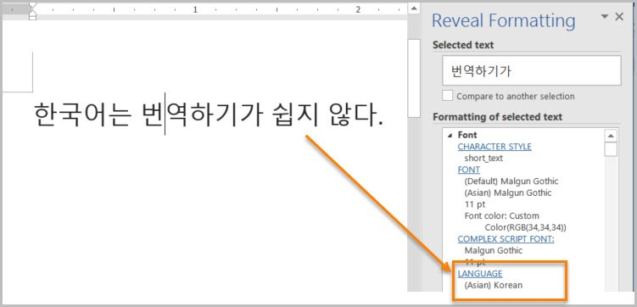

Figure 30: Reveal Formatting pane identifying language of text

* 1. Image/Object Formatting

This section will cover how we need to format things like images and smart shapes in a document.

* + 1. Inline with Text

It is important that tables, images, and other objects be inline with text and not have text wrapped around them. Text wrapping around objects can cause AT to not properly read the content, or to read it in an unintended order that leads to confusion.

You can use the **Accessibility Checker** to identify objects that are not inline with text.

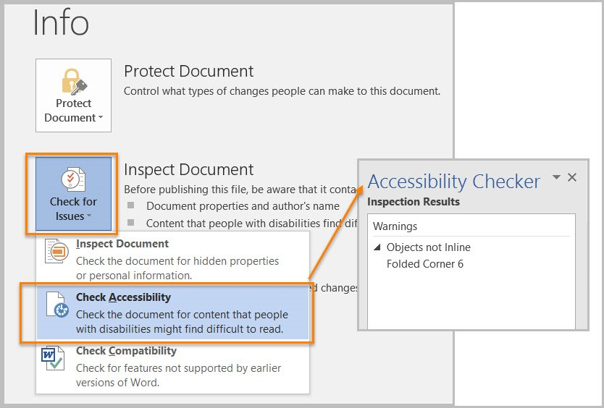

Figure 31: Accessibility Checker report displaying items not properly inline with text.

To fix items not inline with text, you can:

1. Right-click the object.
2. Select the **Size and Position** option from the context menu.

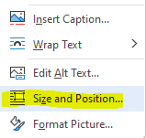

Figure 32: Object right-click menu with "Size and Position" option

1. Navigate to the **Text Wrapping** tab of the resultant **Layout** window that displays.

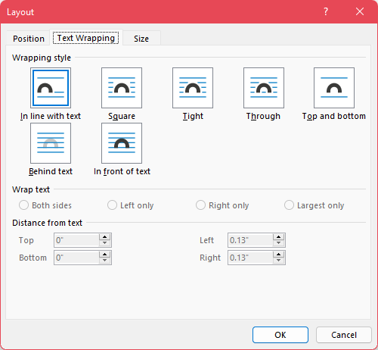

Figure 33: The "Text Wrapping" tab of the "Layout" window.

1. Select the “In line with text” option and click **OK**.
   * + 1. Properly Inserting Images

When you are inserting a picture file, using the **Insert** ribbon in Word will allow you to properly insert them inline with text. This prevents the image from floating about and being in some way wrapped by the text that can interfere with AT reading the content in the proper order.

When pasting an image into a Word document, one thing that can help make sure the image gets properly recognized as an image and is formatted in a way that makes it more accessible, do not simply use ctrl+V to paste the image in. Instead, use the right-click context menu to paste the image in so you can select the “Picture” icon under the “Paste Options.”

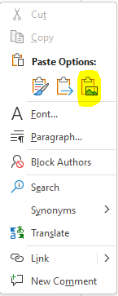

Figure 34: Right-click Context Menu in Word with Picture paste option highlighted.

1. Microsoft Excel Documents

This section will contain information on what you can do to make your spreadsheets made in Microsoft Excel more accessible to anyone who may need to view them.

* 1. Remove Restricted Editing in Excel

As explained in prior sections, documents that have had restrictions turned on cannot be properly tested for Accessibility because those restrictions can interfere with AT reading the document.

In Excel, to remove restrictions, go to “File” tab, “Info”, then “Protect Worksheet.” Select “Restricted Permission by People” and check “Unrestricted Access.” Ensure that end users using AT have access to any passwords necessary to turn off these restrictions.

* 1. Organize Content and Ensure Logical Reading Order

Logical reading order in an Excel spreadsheet is considered left to right and top to bottom with the starting point being cell A1.

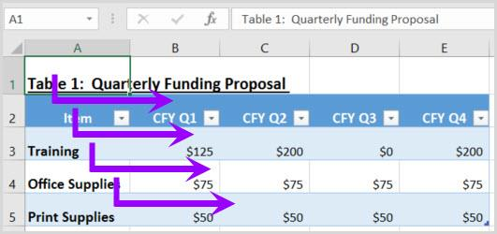

Figure 35: Spreadsheet with content that follows the logical/visual reading order.

To ensure users can follow the flow of information in your spreadsheet, consider the following:

* **If the spreadsheet is part of a workbook,** make sure each spreadsheet tab has a descriptive and unique name. The name of the tab should provide a clue to what information is being covered in the spreadsheet.
* **Use the Cell Style tool to apply Heading levels,** otherwise known as section levels, such as Title and Heading Level 1 through Heading Level 9. To modify the appearance of the Heading Level, right mouse click on the Heading Level and select Modify.
* **If the content in the spreadsheet needs to be in a data table format,** use the Format as Table tool. Identify a table template that best meets your needs and then modify the template by right mouse clicking on the template and select Modify.
* **Lastly, if data cells require special formatting**, use the Format tool to format the cell.
  + Check out the AED CoP testing guides and checklists listed in the **Resources** section of this document.

Additionally, you want to make sure that content doesn’t span over multiple rows or columns, start content in cell A1 every time, and that it can be navigated using the up, down, left, and right arrow keys in a way that matches the visual/logical reading order.

* 1. Data Tables

**Data Tables** are when there is a particular relationship between data in various cells. For instance, when you have a header row that describes the data in the cells beneath it. Data tables are a useful way to organize and present data to users.

Tables must be created using built-in Table features so that assistive technology can properly read a table’s information and infer the relationship between cells.

Do not use pictures of tables or tables with merged or split cells. These are not accessible because the relationship between cells is often not able to be properly conveyed by AT, or AT is unable to read the information at all. Also do not nest one data table inside of another table.

* + 1. Adding an Accessible Table in Excel

Assistive technology users need to be able to identify column headers in data tables to understand the association between table cells and their respective headers.

To create an accessible data table, select “Insert>Table.” In the create table pane, choose the range of cells for your data table. Check the “My table has headers” checkbox in the create table pane. Choose any cell and name your table “Table Tools>Design>Table Name”. Choose the first cell in the header column and/or row and update the column and /or row headings with descriptive names. You can also apply a table name by right mouse clicking on a data cell and select Define Name.

* + 1. Is it a Table or a Picture?

You can test if a table is recognized as a table, by clicking in it. If the **Picture Tools** ribbon appears, the table is an image and is not accessible. If you click it, and the **Table Tools** ribbon appears, then it is properly recognized as a table.

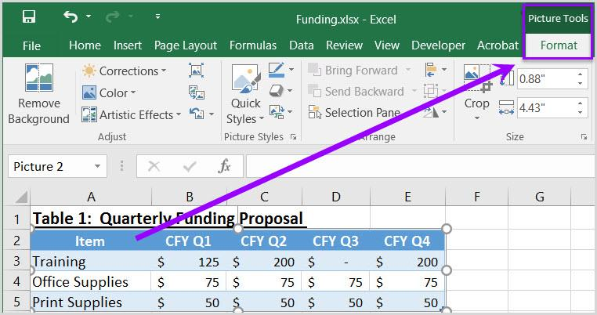

Figure 36: Example Picture of a Table in Excel

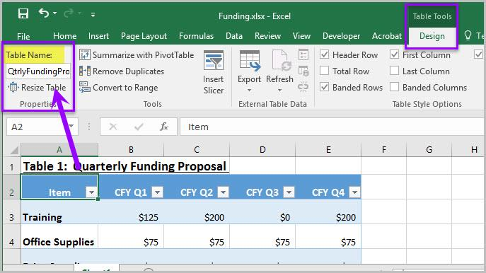

Figure 37: Properly created table in Excel

* + 1. Is the Header Row properly recognized?

Make sure that when you click on the cells in your header row/column are properly recognized. Place your cursor on the first row and/or column of a table cell and see if the worksheet has identified the header row and/or column.

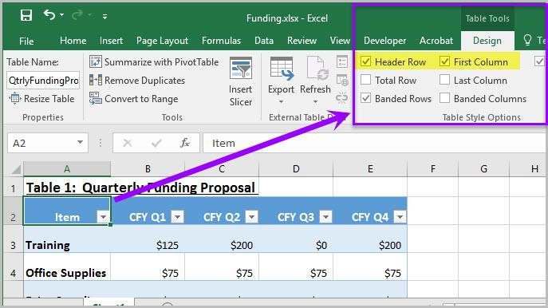

* + 1. Does the table have a name?

You can give tables in Excel a name. This is usually done when you initially create the table with the built-in tools. You can confirm if the table has a name by:

1. Placing your cursor in a table, or otherwise selecting it.
   1. Another method to select tables, if they are properly recognized as a table, is with the “Go To” menu.
   2. The “Go To” menu is accessed by selecting “Home>Editing>Find & Select>Go To” and then selecting any table listed in the options window.
   3. Images of tables will never be listed in the “Go To” options.
2. Once a table is selected, go to the Table Tools ribbon and look under the “Properties” section of the ribbon for the “Table Name” field.



Figure 38: Table Name in Table Properties

* 1. Adding Alt Text to Images and other Objects in Excel

Just like with other documents, Alt Text is important for images and other objects in Excel. However, there are other things you need to consider when adding images and other objects to an Excel file.

In Excel images, objects, shapes, charts, and other non-text elements cannot be anchored/embedded in a cell. Screen reader users cannot access the alt-text of floating elements. Therefore, you must add descriptive text to images and other objects by adding information in a cell near the object, or list the non-text elements and their descriptions in a separate appendix.

1. Microsoft PowerPoint Documents

[Placeholder Text]

* 1. Remove Restricted Editing in PowerPoint

As mentioned in previous sections, having restricted editing turned on can result in a document being inaccessible to AT. It also interferes with proper Accessibility testing of the document. To test, you will need to turn off restricted editing, and provide user’s with the ability to turn it off as well.

To remove restrictions, go to “File” tab, “Info”, then “Protect Presentation.” Select “Restricted Permission by People” and check “Unrestricted Access.”

* 1. Clean Presentation Layout and Logical Reading Order

Keeping your slide layout simple and clean will help make it easier to establish and maintain a logical reading order that AT can follow and makes sense to users. A complex layout can result in users being unable to easily determine the relationship between information and objects on a slide.

Try using the built-in themes available in PowerPoint to get started. These can be accessed when you initially go to create a PowerPoint from the **New** menu, or at any time from the **Themes** section of the **Design** ribbon in PowerPoint. If you select a theme from the **Design** ribbon, you can also view variants of an applied theme, if available, in the **Variants** section.

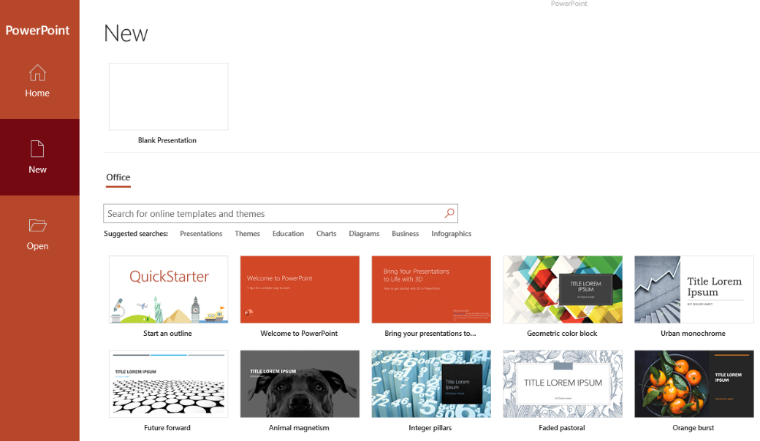

Figure 39:PowerPoint theme options in the New menu

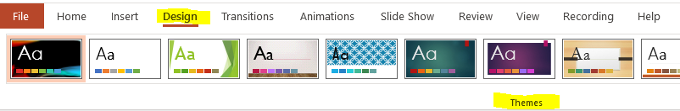

Figure 40: Built-In PowerPoint Themes on the Design tab

A selected theme can be customized to better fit your needs by selecting the **Format Background** option from the **Design** ribbon.

If none of the themes meet your needs, select “View>Slide Master” from the PowerPoint to customize individual slide backgrounds and layouts.

1. **Avoid using colored or patterned backgrounds that make it difficult to read content on the slide.** When using background colors that are similar to the foreground, content might blend into the background.
   1. Similarly, patterned backgrounds might obscure foreground content.
   2. Ensure proper contrast between text and foreground elements.
2. **Use a font that is easy to read.** When possible, avoid using script style fonts such as (**i.e.** Blackadder Italic, Brauhaus 93, and Brush Script MT) Script style fonts can cause eye fatigue.
   1. Additionally, script style fonts are challenging for some individuals with cognitive disabilities or visual impairments to read.
3. While creating an accessible PowerPoint the conditions found in the [AED CoP PowerPoint Testing Checklist](https://www.section508.gov/create/presentations) must be considered.
   1. The answers to all the conditions should be Yes or NA (not applicable).
   2. If a No response is selected, the issue must be resolved before the document can be considered accessible.
   3. Each of these conditions can be tested by visually examining the documents Layout Design and Logical Reading Order.
      1. Slide Layout

The layout of elements on a slide is important to ensure the information is clearly conveyed, and helps to maintain the logical reading order.

Many slides include a slide title, usually near the top of the slide along with a variety of placeholders for other content you may want to add. A descriptive title can help prepare users for what information will be presented on a slide, and thus make navigation easier. Make sure to delete unused placeholders so they aren’t inadvertently picked up by AT.

You can edit a slide’s layout at anytime, though the best ways are when you initially create a new slide, and with the **Slide Master**. Changes made using the Slide Master can be used to alter the **Master Layout**, which will then cause those changes to be applied to any other slide in the presentation that uses that layout.

You can also simply create a wholly new slide layout. If you do, make sure to give your new layout a descriptive name.

* 1. Reading Order

You can customize the tab, or reading, order of elements on a slide to better ensure they are read in a logical order by a AT. Reading order should make sense with the visual layout of the slide. To edit the reading order:

1. Navigate to the **Home** ribbon.
2. Locate the **Editing** section of the ribbon.
3. Click the **Select** drop-down menu, and select the **Selection Pane** option.

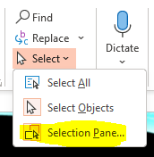

Figure 41: Selection Pane option in PowerPoint.

1. All objects on the slide will be listed in the pane. Reading order starts from the bottom of the list and moves upward. Move objects by clicking their names and using the up/down arrow buttons on the pane, or click and drag items, to move them up and down in the list.

You can also access the Selection Pane by going to the **Drawing** section of the **Home** ribbon, selecting the **Arrange** drop-down menu, and then selecting the **Selection Pane** option from there.

The reading order of items tends to be based on when they were added to the slide. So if you add new items to the slide after editing the reading order, they will be placed at the end of the reading order.

* + 1. Hiding Objects in Selection Pane

To the right of each item in the Selection Pane list is an eye icon. Toggling it can cause items to be hidden visually, but they will still be read by a screen reader.

* 1. Formatting Columns

Formatting columns is important in a PowerPoint for the same reasons that it is important in Word. If you just make items visually appear to be columns on a slide, they may not be interpreted properly. They could be read in the wrong order, or lines could be read together that don’t go together.

Formatting the text into columns using the **Column** options found in the **Paragraph** section of the **Home** ribbon, will best ensure Accessibility with AT. You can also use this menu option to verify if text was properly formatted into columns. Simply place your cursor in the text that appears to be in columns and open the menu. If you see an option highlighted that matches the number of columns on the screen, the text was properly formatted with the built-in column tool.

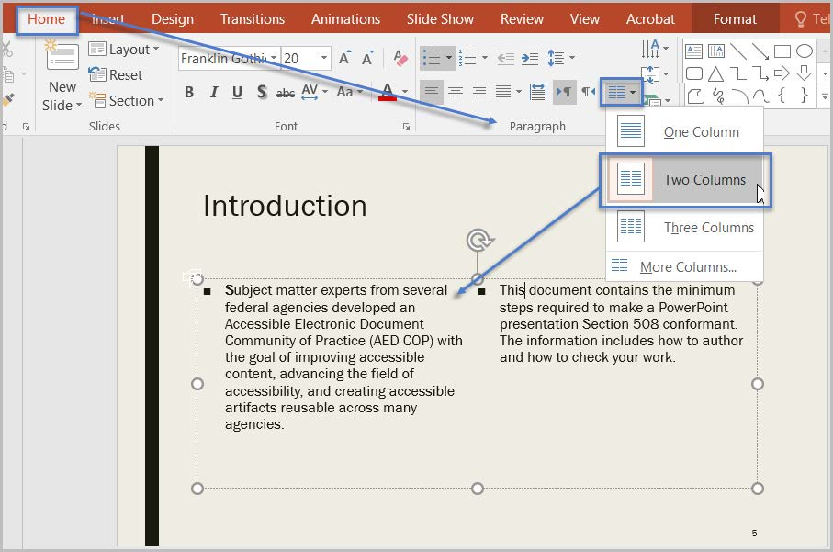

Figure 42: Text formatted into 2 columns with the Column options in PowerPoint.

* 1. Formatting Lists

Lists should be properly formatted using the built-in list tools in PowerPoint found in the **Paragraph** section of the **Home** ribbon. If you place your cursor in text that appears to be in a list, and one of the list types (**i.e.** bullet lists or numbered lists) does not highlight, the list was not properly formatted.

AT cannot infer that list items are in a list just because they were visually formatted to look like a list. They must be made into a list using the built-in list tools to be properly recognized as such. You can make custom list styles in the list options if you so choose, and this is fine. Custom lists styles made using the built-in list options will be recognized as lists.

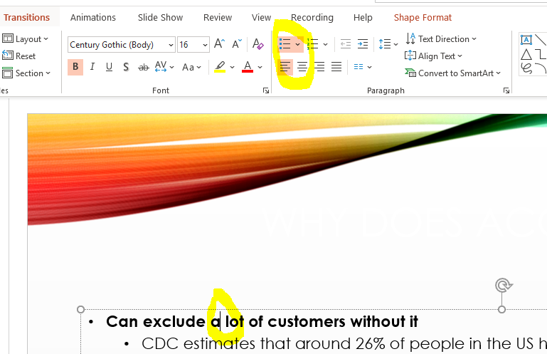

Figure 43: Bulleted style list built using built-in styles

* 1. Auto-Creating Data Tables

To get your table off on the right foot towards being accessible, it is important to use the built-in table creation tools in PowerPoint. The most common ways to do this are by going to the **Insert** ribbon and selecting the **Table** from the **Tables** section of the ribbon to open the available table insert options.

From there you can either:

* Hover your mouse over the boxes shown to select the size for your table, clicking once you have the number of rows and columns you want highlighted, or
* You can select the **Insert Table** option from the menu and manually type in how many columns and rows you want your table to be.

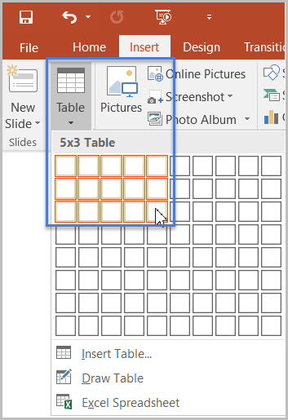

Figure : Table insert options

If you need a more complex data table that has multiple header rows, 1 or more header columns, and/or merged or split cells, then you must convert the presentation to an accessible format such as a PDF document remediated for accessibility. Complex data tables cannot be created and made accessible in Microsoft PowerPoint.

* + 1. Identify a Header Row

To identify the headers in a table:

1. Click inside the table. The **Table Tools** options should become visible, and the **Design** ribbon should be open.
2. If the top row of the table contains headers for each column (most tables do), make sure the **Header Row** checkbox is checked.
3. If the first column of the table contains headers for each row, make sure the **First Column** checkbox is checked.

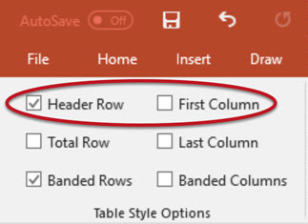

Figure : Table Style Options in PowerPoint

* + 1. Table Color Contrast and Borders

It is also important to ensure that you select a table style that gives enough contrast to the header row to make it more visually identifiable.

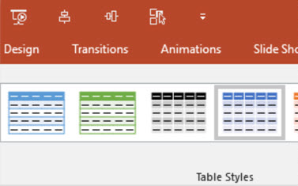

Figure : Table styles displaying some of the color and row style options available.

* + 1. No Pictures of Tables

As with other document formats, you do not want to include pictures of tables. You want to instead recreate the table using the built-in table creation tools in PowerPoint. Pictures of tables cannot be interpreted by AT for users in a meaningful way. You can tell if a table is an image or a properly created table by selecting the table and seeing what set of tools shows up in the menu ribbon. If **Picture Tools** shows up instead of **Table Tools**, your table fails because it is a picture instead of a properly created table.

* 1. Headers and Footers in PowerPoint

In PowerPoint files, it is possible to add the Header and/or Footer to the reading order. To accomplish this, we must enable Headers and Footers and ensure they display in the Selection Pane.

To enable Headers and Footers in your presentation:

1. Select the “Insert” ribbon.
2. In the “Text” group, select “Header & Footer.”
3. Check the “Footer” option.
4. Type in vital information, and select “Apply.”

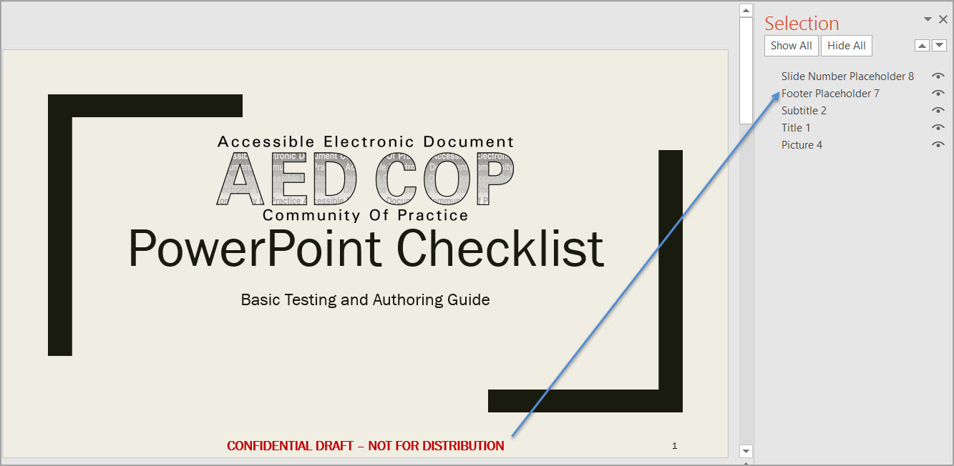

Table : Selection Pane in PowerPoint displaying Footer item in the reading order.

* 1. Language Formatting

Ensuring elements of the document that are in a language other than the predominant one must be marked as such. This ensures AT properly recognizes and pronounces them to avoid miscommunication.

If the presentation contains words or phrases in a language other than the predominant language:

1. Highlight the relevant text.
2. Go to the “Review” tab.
3. In the “Language” group select the “Language” Button.
4. The choose “Set Proofing Language.”
5. Select the relevant language the selected portion is in.
6. Click **OK**.
7. PDF Documents

[Placeholder Text]

Identify the various elements that make up a PDF document

Describe the 37 different tags and their functions

Use the Accessibility PDF Checklist

Convert documents into PDFs

Test a PDF for accessibility via a visual check

Use the Accessibility Full Check tool in Adobe Acrobat DC Pro

1. Resources

This section will list out a variety of resources that information was pulled from and/or may provide additional context while you learn about the topics covered in this document.

* 1. Government Sites and Documents

Links and information in this section come from a variety of government sources.

* [Section 508 Official site](https://www.section508.gov/)
  + [Create Accessible Digital Products | Section508.gov](https://www.section508.gov/create)
  + [Test for Accessibility | Section508.gov](https://www.section508.gov/test)
* [U.S. Access Board](https://www.access-board.gov/)
* [US General Services Administration (GSA)](https://www.gsa.gov/)
  1. Microsoft Sites and Documents

Links and information in this section come from a variety of Microsoft sources.

* [Accessibility Technology & Tools | Microsoft Accessibility](https://www.microsoft.com/en-us/accessibility)
* [Accessibility fundamentals - Learn | Microsoft Docs](https://docs.microsoft.com/en-us/learn/paths/accessibility-fundamentals/)
  1. W3C Sites and Documents

Links and information in this section come from a variety of W3C sources.

* [Web Content Accessibility Guidelines (WCAG) Overview | Web Accessibility Initiative (WAI) | W3C](https://www.w3.org/WAI/standards-guidelines/wcag/)
  1. AED CoP Links

These links refer to various pages and downloadable documents relating to AED CoP.

* [Microsoft Word Files and Tips](https://www.section508.gov/create/documents)
* [Microsoft Excel Files and Tips](https://www.section508.gov/create/spreadsheets)
* [Microsoft PowerPoint Files and Tips](https://www.section508.gov/create/presentations)
* [PDF Files and Tips](https://www.section508.gov/create/pdfs)
* [Files and Tips relating to other document formats](https://www.section508.gov/create/presentations)
  1. Additional Resources

Links and information in this section come from various other sources.

* [Section 508 Amendment to the Rehabilitation Act of 1973 - Wikipedia](https://en.wikipedia.org/wiki/Section_508_Amendment_to_the_Rehabilitation_Act_of_1973)
* [Web Content Accessibility Guidelines - Wikipedia](https://en.wikipedia.org/wiki/Web_Content_Accessibility_Guidelines)
* [WAI-ARIA Overview | Web Accessibility Initiative (WAI) | W3C](https://www.w3.org/WAI/standards-guidelines/aria/)

1. Glossary

* **AED CoP** – stands for **Accessible Electronic Document Community of Practice**, and is described in section 1.1.
* **AT** – Accessible/Assistive Technology, any technology used to help improve Accessibility. This can be things like screen readers, refreshable braille displays, ARIA and more.
* **DHS** – United States Department of Homeland Security
* **ICT** – Information and Communication Technologies, which is the term used to define the materials covered by Section 508.
* **OAST** – Office of Accessible Systems and Technology, an office under the DHS.
* **POUR** – The 4 primary principles of WCAG, which are further defined in section 2.1.1.
* **SME** – stands for **Subject Matter Expert**, and is an individual who is considered an expert in a particular topic.
* **W3C** – World Wide Web Consortium
* **WAI-ARIA** – stands for **Web Accessibility Initiative – Accessible Rich Internet Applications**. This is a technical specification written by the W3C, which is commonly used to help build interactive web content that is more accessible to individuals with disabilities. You can learn more from the [WAI-ARIA Overview](https://www.w3.org/WAI/standards-guidelines/aria/) page on the W3C site.
* **WCAG –** Web Content Accessibility Guidelines, described in section 1.3.

1. References

Images are sourced from either Microsoft’s [Accessibility Fundamentals course](https://docs.microsoft.com/en-us/learn/paths/accessibility-fundamentals/), [DHS OAST Training Resources](https://training.section508testing.net/), or are screenshots taken using either my installed copy of the Microsoft Office 365 desktop applications or from the Office 365 browser applications.

1. Change Log

The table in this section will help with tracking changes made and the author of those changes.

| Date  (YYYY-MM-DD) | Version | Author | Details |
| --- | --- | --- | --- |
| 2021-07-30 | 1.0 | Elizabeth Gray | Initial document creation. |
| 2021-08-04 | 2.0 | Elizabeth Gray | Built out the Word and Excel sections.  Created a section for shared issues that are resolved in a similar manner regardless of doc type. |